LAW ENFORCEMENT RESPONSE TO UNIDENTIFIED ANOMALOUS PHENOMENA: IMPLICATIONS OF OPERATIONAL HAZARDS, FIELD DETECTION, AND POLICY PATHWAYS

John Tedesco¹, Gerald Tedesco², Keith L. Taylor, Sr.³, Keith L. Taylor, Jr.⁴
¹Nightcrawler Eye on the Sky, Long Island, USA, e-mail: engineert39@aol.com
²Nightcrawler Eye on the Sky, Long Island, USA, e-mail: imoneguy088@gmail.com
³John Jay College of Criminal Justice, New York, USA, e-mail: DrKeithLTaylorSr@gmail.com
⁴Dwight-Englewood School, Englewood, USA, e-mail: Keithltjr@gmail.com

РЕАГУВАННЯ ПРАВООХОРОННИХ ОРГАНІВ НА АНОМАЛЬНІ АЕРОКОСМІЧНІ ЯВИЩА: МОЖЛИВІ ОПЕРАЦІЙНІ НЕБЕЗПЕКИ, ШЛЯХИ ВИЯВЛЕННЯ ТА РОЗРОБЛЕННЯ ПОЛІТИК РЕАГУВАННЯ

Джон Тедеско¹, Джеральд Тедеско², Кіт Л. Тейлор-ст.³, Кіт Л. Тейлор-мол.⁴
¹«Nightcrawler Eye on the Sky», Лонг-Айленд, США
²«Nightcrawler Eye on the Sky», Лонг-Айленд, США
³Коледж кримінального правосуддя імені Джона Джея, Нью-Йорк, США
⁴Школа Дуайта-Енглвуда, Енглвуд, США

Анотація: Правоохоронці все частіше стикаються з неідентифікованими аномальними явищами (ААЯ, UAP) – подіями, що створюють унікальні операційні проблеми та проблеми безпеки. У цій статті розглядаються історичні та сучасні інциденти, включаючи зіткнення із ААЯ в окрузі Маршалл, штат Вісконсин, у 1979 році та зіткнення з плазмовою кулею в окрузі Ферфілд, штат Коннектикут, у 2022 році, щоб підкреслити аспекти професійної небезпеки цих явищ. Використовуючи дані польових досліджень Джона та Джеральда Тедеско, дане дослідження детально описує мультимодальний підхід до виявлення, що включає радіолокаційні, теплові та мультиспектральні датчики для детектування та ідентифікації ААЯ. Методологія пропонує відтворювану модель готовності правоохоронних органів, поєднуючи суб’єктивні судження очевидців із даними, вимірюваними за допомогою приладів. Особливості і наслідки застосування політик реагування обговорюються через інтерв'ю з керівництвом AARO, підкреслюючи необхідність стандартизованої звітності офіцерів, навчання реагування на ААЯ та міжвідомчої інтеграції даних. Результати свідчать про те, що інциденти із ААЯ потребують визнання не лише як наукових загадок, але й як професійних небезпек, що потребують формальної інтеграції політик реагування на АЯ в системи громадської безпеки.
Keywords: UAP, Law Enforcement, Detection, Field Research, Policy Integration, Public Safety
Ключові слова: ААЯ, UAP, правоохоронні органи, виявлення, польові дослідження, інтеграція політик реагування, громадська безпека

Introduction. Law enforcement officers have long faced unexpected and sometimes hazardous encounters with Unidentified Anomalous Phenomena (UAP), encounters that challenge not only their personal safety but also agency preparedness for UAP incidents. One of the most notable examples is the August 1979 Marshall County, Minnesota UAP incident, in which Deputy Sheriff Val Johnson collided with a brightly lit object with his patrol car while driving on a local road. The event left his patrol car physically damaged, his wristwatch and vehicle clock mysteriously stopped for 14 minutes, and Johnson suffered with temporary blindness similar to welder’s burns. The case remains one of the most thoroughly documented police–UAP encounters, underscoring both the potential for officer injury and the importance of forensic evidence in UAP cases.¹
Introduction. Law enforcement agencies worldwide have periodically confronted Unidentified Anomalous Phenomena (UAP), often under conditions that jeopardize officer safety and operational integrity. Historical encounters such as the 1979 Marshall County, Wisconsin incident, where Deputy Val Johnson’s vehicle collided with an anomalous lighted object, and modern cases like Officer Robert Klein’s 2022 Fairfield County, Connecticut encounter, demonstrate recurring hazards. Recent analytical work by John and Gerald Tedesco represents a paradigm shift toward evidence-based UAP field research. Their Nightcrawler Eye on the Sky initiative integrates radar, multispectral, optical, and thermal sensors, producing one of the most comprehensive multimodal datasets in UAP documentation.
The goal and objectives of the study. The study aims to establish a standardized framework for law enforcement preparedness regarding UAP encounters. Key objectives include identifying operational risks faced by officers, validating multimodal detection methodology, and proposing a policy model linking local agencies to national oversight structures. Previous research lacked systemic methods for correlating radar, thermal, and visual data across simultaneous observations. This study addresses those gaps through reproducible instrumentation and classification frameworks.
Main text. The Tedescos’ field methodology integrates millimeter-wave Doppler radar, FLIR thermal imaging, and hyperspectral detection in a mobile platform environment. Over four years, their deployments across Suffolk County, New York, documented multiple anomalous aerial signatures. Figures captured via optical and thermal devices (e.g., Nikon P1000 and HD FLIR) reveal spherical luminous objects exhibiting non-ballistic motion. ADS-B and NOTAM data were used to exclude conventional aircraft and verify anomalies.
A more recent encounter illustrates that these incidents are continual and present unknown risks to law enforcement officers. In April 2022, former Weston, Connecticut police officer Robert Klein reported an orb-like object near a reservoir that emitted plasma-like light, temporarily blinded him, and maneuvered instantaneously across a nearby large body of water. Officer Klein captured video evidence of the event, adding another troubling case to the significant number of known police–UAP incidents.²
In an August 2025 interview of AARO Director Jon Kosloski on astrophysicist Dr. Neil de Grasse Tyson’s StarTalk podcast, Kosloski recounted an officer’s dramatic response to a black triangle UAP the size of a Toyota Prius, in which the officer drove his cruiser backwards at 100 miles per hour to evade the object.³ Similarly, in a November 2024 unpublished professional conversation, former Acting Director Tim Phillips emphasized to co-author Dr. Keith Taylor the broader issue of officer vulnerability during UAP incidents, particularly the unpredictability of these events in rural patrol settings.⁴
Together, these cases and perspectives illustrate that UAP encounters represent not only a scientific mystery but also a law enforcement occupational hazard. Addressing these risks requires integrating lessons from past incidents, current field reports, and emerging technical strategies into first responder training, detection equipment and policy frameworks.⁵
Data-Rich Model Serves as the Foundation for Future Research. In recent years, the investigative efforts of John and Gerald Tedesco—founders of the nonprofit Nightcrawler Eye on the Sky initiative—have provided one of the most systematic attempts to monitor Unidentified Aerial Phenomena (UAP) activity using multimodal sensors. Their approach represents a significant shift from relying solely on anecdotal officer testimony toward a framework grounded in scientifically measurable field evidence. By deploying an array of advanced technologies, including radar, multispectral, optical, and thermal sensors in rural New York locations, the Tedescos have created a data-rich model for documenting anomalous activity. This model not only enhances our understanding of UAPs but also sets a precedent for future research in this developing field.
The innovative methodology employed by the Tedescos is noteworthy for its comprehensive nature. By integrating various types of sensors, they are able to capture a wide spectrum of data that can be analyzed from multiple perspectives. For instance, radar technology allows for the detection of objects at considerable distances, providing crucial information about their speed and trajectory. Meanwhile, multispectral sensors can detect light across different wavelengths, revealing details that are invisible to the naked eye. Optical sensors contribute high-resolution imagery, while thermal sensors can identify heat signatures, which are particularly useful in distinguishing between natural phenomena and potential UAPs. This multifaceted approach not only enriches the dataset but also enhances the reliability of the findings, as corroborating evidence from different sensor types can lead to more robust conclusions.
Moreover, the Tedescos’ initiative underscores the importance of collaboration within the scientific community. By sharing their findings and methodologies with other researchers and organizations, they foster an environment of transparency and collective inquiry. This collaborative spirit is essential in a field often shrouded in skepticism and misinformation. The Nightcrawler Eye on the Sky initiative serves as a model for how interdisciplinary cooperation can yield significant advancements in our understanding of UAPs, encouraging other scientists to adopt similarly rigorous methodologies in their investigations.
The implications of the Tedescos’ work extend beyond mere documentation of UAPs; they challenge the prevailing narratives surrounding these phenomena. By providing empirical evidence, they invite a reevaluation of the assumptions that have long dominated discussions about UAPs. This shift toward a more scientific approach not only legitimizes the study of UAPs but also opens the door for further exploration into the potential implications of these phenomena on our understanding of physics, aerospace technology, and even the possibility of nonhuman intelligence.
Technical Framework. The detection suite used by the Tedescos integrates several sensor modalities, creating a robust and multifaceted system for monitoring Unidentified Aerial Phenomena (UAP). At the core of this suite is a millimeter-wave Doppler radar unit, which not only establishes object velocity and trajectory profiles but also provides unique audio frequency spectral signatures. This dual capability allows for a more nuanced understanding of the objects being monitored, as the audio signatures can offer additional context regarding the nature and behavior of the detected phenomena. Such information is invaluable for distinguishing between various types of aerial activity, whether they are conventional aircraft, drones, or unexplained anomalies.
Complementing radar technology, FLIR (Forward Looking Infrared) thermal imagers are employed to detect unexpected heat signatures in the long-wave infrared spectrum. This capability is particularly advantageous in low-visibility conditions, such as during nighttime or inclement weather, where traditional visual observation methods may fall short. The ability to identify temperature variations allows the Tedescos to pinpoint objects that may otherwise be hidden from view, thereby enhancing the overall effectiveness of their monitoring efforts.
In addition to these technologies, electro-optical multispectral detectors and hyperspectral cameras play a crucial role in capturing both visual data and information that lies beyond human perception. These advanced imaging systems cover a broad range of the electromagnetic spectrum (EM), which is essential for comprehensive analysis. It is important to note that human visible acuity constitutes less than 1 percent of the entire EM spectrum, highlighting the significance of utilizing these sophisticated sensors. By extending the range of detection beyond what the human eye can perceive, the Tedescos’ system enables cross-verification of objects, including those that are invisible to the naked eye. This capability not only enriches the dataset but also increases the likelihood of accurately identifying and classifying UAPs.
By networking these systems into a coordinated mobile platform, the Tedescos ensure that potential anomalies can be simultaneously observed across a broad spectral domain. This integration allows for real-time data collection and analysis, providing first responders with a broader range of perception within their surrounding environment. The ability to monitor multiple spectral bands concurrently enhances situational awareness, enabling responders to make informed decisions based on comprehensive data rather than limited observations.
Moreover, this coordinated approach fosters a more holistic understanding of the phenomena being observed. By synthesizing data from various sensors, the Tedescos can create a more complete picture of the environment, which is crucial for identifying patterns and anomalies that may otherwise go unnoticed. This level of detail is particularly important in the context of UAP investigations, where the stakes can be high and the need for accurate information is paramount.
Methodology. The research conducted by John and Gerry Tedesco over a period of four years focused on Unidentified Aerial Phenomena (UAP) off the coast of Long Island, New York. They employed multispectral electro-optical devices and radar, specifically a 3 cm X-band radar in two scan geometries (x- and y-axis), to address challenges in object detection, observation, and characterization. Secondary detection methods included high-frequency and low-frequency detectors, along with spectrum analyzers that utilized electromagnetic field transducers to capture a wide range of spectral data, including visible light, near-infrared, and various forms of ionizing radiation.
The study emphasized innovative detection designs, such as active radar and extended infrared spectral range, which enabled the observation of unique light phenomena, including spheroids that exhibited elusive characteristics. The findings highlighted that the detected objects primarily emitted light outside the visible spectrum, underscoring the limitations of human electromagnetic perception.
The Tedesco team’s approach enhances the credibility of their research by providing detailed methodologies and instrument explanations, making the findings accessible to both specialized researchers and the first responder community. Their work exemplifies the ongoing quest for knowledge in science, characterized by integrity, commitment, and a balance of skepticism with evidence-based inquiry. This comprehensive approach establishes a model for law enforcement first responders in the field.
Applying an Exclusion Hypothesis: Determining What Constitutes Known Objects from Unknown Objects by Defining and Differentiating Their Characteristics. One of the most significant challenges in UAP research is the identification of unusual luminous activity in the sky, particularly the differentiation between known objects and unknown objects. This process involves not only categorizing these entities but also understanding their unique characteristics. For any researcher in this field, it is essential to recognize that no two nights of observation are the same. Various confounding variables, such as weather-based changes and incoming fronts, can affect visual acuity. Additionally, the presence of air traffic, drones, Starlink satellites, celestial phenomena, and atmospheric occurrences complicates the task of distinguishing between known and unknown objects. To address these challenges, they employ a sophisticated instrumentation platform composed of various electro-optical devices, active radar systems, electromagnetic spectrometers, and sensor arrays mounted on a mobile laboratory. This methodical, multimodal field approach is designed to enhance observational capabilities and improve classification accuracy.
When observations take place near municipal airports, mapping out the flight corridor provides baseline information, offering additional details about aircraft flights such as approaches and departures. Flight Tracker software, which displays ADS-B map data, is employed for this purpose. ADS-B, which stands for Automatic Dependent Surveillance-Broadcast, is a modern aviation technology that is becoming the primary method for tracking aircraft, eventually replacing traditional radar.
In simple terms, an ADS-B equipped aircraft determines its own position using GPS (or another navigation system) and then automatically broadcasts this information to anyone who is listening. This is why it is called “Automatic Dependent Surveillance-Broadcast.” In addition to using ADS-B data, the application known as “Notice to Airmen (NOTAMs)” is used. A NOTAM (Notice to Air Missions) is a notice filed with an aviation authority to alert aircraft pilots of potential hazards along a flight route or at a location that could affect the flight. NOTAMs are a crucial part of aviation safety because they provide real-time, time-sensitive information not known far enough in advance to be publicized by other means, such as aeronautical charts.
Object Classifications: The Knowns. A “Known” classification refers to the identification of conventional aircraft, which includes jets, prop-driven planes, rotor-driven vehicles (helicopters), commercial airliners, maritime surveillance drones, satellites, and satellite debris. This classification also encompasses various forms of biomass, such as birds, flocks of birds in murmuration, insect swarms, and colonies of bats in flight. Natural phenomena, including bioluminescence, atmospheric auroras, cloud aberrations (atypical cloud appearances due to solar or lunar lighting and shadows), and other atmospheric lighting phenomena (such as prism effects caused by ice crystals), also fall under this category. Additional known entities include ball lightning, plasmas, and natural celestial objects such as stars, meteors, and comets.
One of their primary goals during the early night hours (before midnight) is to allocate time for distinguishing and classifying known air traffic from the unknown. Their research area at Robert Moses State Park is located thirty-eight miles east of New York’s largest airport, John F. Kennedy International Airport (JFK), which handles approximately 2,400 daily flights.⁶ Half of these flights are arrivals, which can create confusion if air traffic is not accurately identified. By employing ADS-B (Automatic Dependent Surveillance–Broadcast) data, visual references from superzoom cameras, and thermal cameras, along with a working knowledge of the flight corridor, they can mitigate identification issues. Their sky-watch monitoring typically begins after midnight, when flight schedules are minimal, allowing for clearer observations.
For instance, in Figure 1, they identify a pinpoint of light using a Nikon P1000 superzoom camera. This camera features a 125x optical zoom (250x digital), a 24–3000 mm telephoto lens, and image stabilization through a dual detection optical vibration reduction system, which effectively stabilizes images for both x- and y-axis motion.
Given that half of the 2,400 daily flights are arrivals, this variable is especially important when investigating anomalous objects. Aircraft lighting systems during approach can easily confuse untrained observers. Departing flights pose less concern as they move away from the airport, while arriving flights remain within the corridor, a known geographical location. Their team strategically avoids observing this southwestern section of the sky during peak flight times, which extend from 6:00 a.m. until midnight. Instead, their field research focuses southeastward, away from the corridor during these hours. Favorable conditions for fieldwork are generally found in the early morning after midnight.

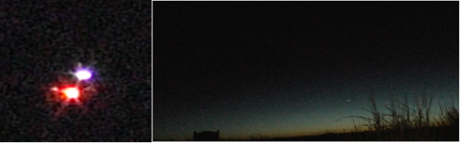
Figure 1. Pinpoint of light captured with a Nikon P1000 superzoom camera, demonstrating 125x optical zoom capability.

Understanding Confounding Variables: The Airport Flight Corridor. Whenever the skies are active with commercial air traffic, various confounding variables emerge that can influence object observation and classification. A thorough understanding of these variables—and the ability to recognize identifiable features—is essential for accurate identification. Key considerations include:
- Circular or Elliptical Flight Patterns: Within the airport flight corridor, aircraft often exhibit circular or elliptical flight paths, particularly when holding for approach. This is a standard air traffic control (ATC) procedure designed to delay aircraft until clearance to proceed is granted. To a ground observer, an airliner in a holding pattern may appear as an object hovering or moving minimally for an extended period.
- Observed Glide Slopes: Low-horizon approaches can create visual challenges, as the angle of descent may obscure the aircraft’s true position.
- Aspect Ratios: An aircraft’s structural length and shape can appear distorted depending on orientation and observer perspective, complicating identification.
- Aircraft Lighting Systems: Lighting patterns—including location, intensity, flashing versus steady, and color—are key identification features. Navigation lights on wing tips (green on the starboard/right side, red on the port/left side), as well as white lights on the tail (empennage) and nose, provide visual orientation cues.
- Anti-Collision Lights: Bright red flashing beacons located on the aircraft’s dorsal and ventral surfaces serve as safety and identification features.
- Landing Lights: Downward-tilted, high-intensity white lights, mounted ventrally near the fuselage, indicate landing intentions and remain illuminated until the aircraft descends below 10,000 feet.
- Taxi Lights: Lights mounted on the nose wheel strut become visible when aircraft travel along taxiways and runways.
- Formation Infrared (IR) Lights (Military): Used in stealth operations, these lights complicate identification efforts, particularly in low-light conditions.
By systematically accounting for these confounding variables and applying a comprehensive classification system, they enhance their ability to differentiate between known and unknown objects in the sky. This structured approach not only improves the accuracy of their observations but also deepens their understanding of the complexities surrounding UAP activity. As they refine their methodologies and expand their research, they remain committed to advancing the field and uncovering the mysteries of the skies.
Defining Equipment Standards: Equipment Necessary for Establishing Field Research. To effectively conduct field research in the study of Unidentified Aerial Phenomena (UAP), a comprehensive selection of specialized equipment is essential. This equipment must be capable of capturing a wide range of electromagnetic (EM) wavelengths, enabling researchers to gather data that extends beyond human perceptual abilities. The following outlines the key components necessary for establishing a robust field research program.
Hyperspectral Cameras. Hyperspectral cameras are critical tools for capturing data across both the visible and near-infrared spectral ranges, specifically from 400 nanometers (nm) to 1200 nm. The visible spectrum covers wavelengths from 400 to 700 nm, while most consumer cameras extend from roughly 350 nm to 900 nm. Hyperspectral cameras allow researchers to analyze the spectral signature of objects, thereby identifying materials and detecting anomalies that may not be visible to the naked eye.
Passive night-vision (NV) cameras can extend detection into the near-ultraviolet (350 nm) and lower ranges of infrared, reaching as far as 1200 nm. While these devices enhance visibility in low-light conditions, they may inhibit the passive capabilities of low-light image sensors, such as Sony Starvis sensors, which are designed to detect infrared light beyond 1000 nm. This limitation must be carefully considered when selecting NV equipment, as it can reduce overall research effectiveness.
Multispectral Detectors. Multispectral detectors are equally important, designed to capture precise wavelength regions across the electromagnetic spectrum. These detectors can target ultraviolet A, B, and C at the upper end, as well as near-infrared, short-wave infrared, and long-wave infrared at the lower end. The ability to isolate and analyze specific wavelengths is critical for identifying biological activity, atmospheric conditions, and potential UAP signatures.
A class of highly sensitive sensors has recently emerged, capable of detecting extremely low levels of light. Manufacturers such as Hamamatsu produce binary-type phototube detectors that trigger for defined periods when exposed to light.⁷ Of note, components of the UVC Detector device designed and built by the Tedesco brothers employ this technology.⁸ These sensors are invaluable for capturing subtle environmental changes that may indicate the presence of UAPs or other anomalous activity.
Essential Equipment for First Responders. First responders require a suite of basic sensors and protective tools to expand their observational capabilities. These include:
- Portable Hyperspectral and Multispectral Sensors – Lightweight and compact detectors that can be transported and deployed in diverse environments.
- Thermal Imaging Cameras – Instruments capable of detecting heat signatures in low-visibility conditions, revealing objects invisible through conventional optics.
- Active Millimeter-Wave Doppler Radar Systems – Systems that track the movement of objects in real time, providing velocity and trajectory data. Integration with optical and thermal imaging enhances aerial tracking. Millimeter-wave radar guns, commonly available to law enforcement, incorporate radio frequency and infrared light technologies (such as LIDAR). The Tedesco brothers have modified similar technologies for UAP surveillance.
- Personal Protective Equipment (PPE) – UVC eye protection (eyeglasses, sunglasses, or goggles made from either glass or plastic) is sufficient to block ultraviolet light. Electromagnetic interference (EMI) and electromagnetic pulse (EMP) protection can be achieved with EMI fabrics or blankets. Protection from ionizing radiation can be reduced with a medical radiological apron, though the best safeguard is minimizing exposure using portable Geiger counters or scintillation detectors.
- Data Processing Software – Advanced software to analyze large datasets, visualize findings, identify patterns, and generate field reports.
- Mobile Laboratory Setup – A mobile unit equipped with power supplies, data storage, and processing tools, enabling on-site data analysis and real-time decision-making.
- User-Friendly Interfaces – Intuitive controls that allow rapid deployment and immediate analysis without requiring extensive operator training.
Applying Data Fusion: Identification Protocol. Establishing a field research program for the study of UAPs requires a diverse array of specialized equipment capable of capturing and analyzing a wide range of electromagnetic wavelengths. Hyperspectral cameras, multispectral detectors, thermal imaging cameras, and active radar systems all play critical roles in enhancing observational capabilities. By carefully selecting and integrating these tools, researchers and first responders can improve their ability to differentiate between known and unknown objects in the sky, ultimately advancing our understanding of UAP phenomena. As technology continues to evolve, the potential for more sophisticated and sensitive equipment will further enhance the field of UAP research, paving the way for new discoveries and insights.
Automatic Dependent Surveillance–Broadcast (ADS-B) is a real-time surveillance technology and form of electronic conspicuity in which an aircraft determines its position via satellite navigation or other sensors and periodically broadcasts that position, enabling it to be tracked. Air traffic control ground stations can receive this information as a replacement for secondary surveillance radar, since no interrogation signal is required from the ground. Other aircraft can also transmit and receive point-to-point data to provide situational awareness and allow self-separation. ADS-B is automatic, requiring no pilot or external input. It is independent of the pilot but depends on the accuracy of the aircraft’s navigation system data.⁹
Several ADS-B-related air traffic software applications are available. In their research, they use two primary platforms to identify known air traffic: FlightRadar24, shown in Figure 2, and AirNav. This broadcast surveillance method for air traffic control provides real-time flight tracking data, which allows them to determine active air traffic during peak hours of observation. By using this information, commercial traffic can be distinguished from unknown aerial observations. Both applications include a range of analytic tools that support ongoing research.¹⁰

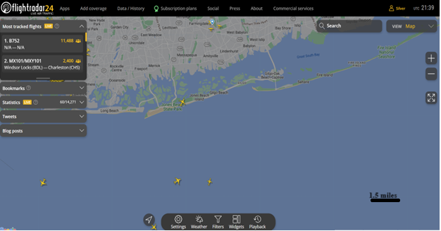
Figure 2. ABS-D using Flightradar24 taken at Robert Moses State Park

Multispectral Electro-Optics and Thermal Imaging. Multispectral electro-optics are employed across a wide spectral range—from ultraviolet (UV) and visible light to the far-reaching hyperspectral range—to detect identifiable signatures. Military aircraft may use formation lights, which occupy a portion of the infrared (IR) spectrum, to maintain stealth during operations. IR lighting, however, is generally not a factor in normal commercial air traffic, though it can be an exception for some stealth military aircraft.
Forward-Looking Infrared (FLIR) is a high-resolution, long-wave infrared (LWIR) thermal imaging system that incorporates a telescopic system capable of 40x magnification. This technology enables the acquisition of unique and specific thermal signatures of aerial objects. A thermal signature is defined by two parameters: emissivity and reflectivity, which maintain an inverse relationship. The imaging data provided by FLIR systems are valuable for distinguishing heated engines and propulsion systems, surface details, geometry, silhouettes, shapes, and the composite material of structural surfaces, such as metals like aluminum.¹¹
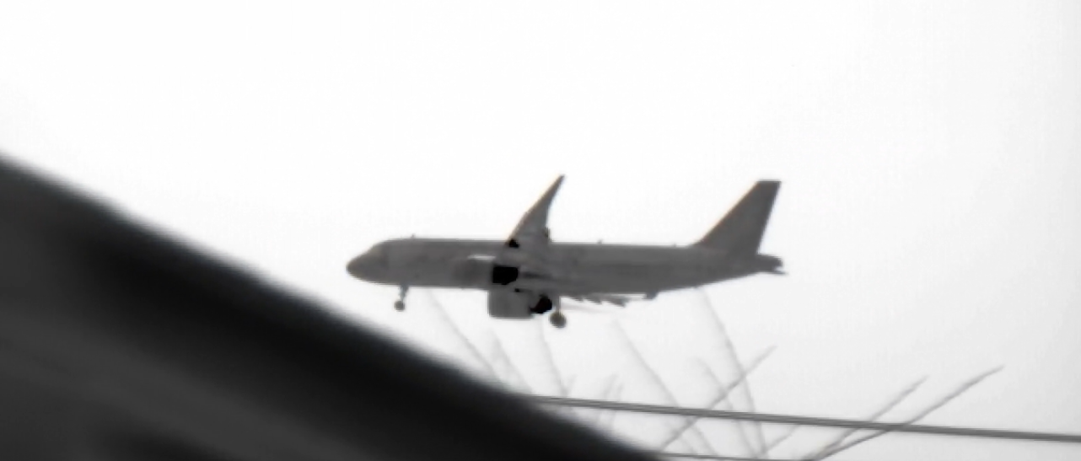
Figure 3. Thermal image taken by a thermal camera

Figure 3 is a photograph of a Boeing 737 taken by a monocular ATNOTS 4T HD FLIR thermal camera at an approximate elevation of 1,000 feet on a glide path into Long Island MacArthur Airport. The darker areas in the black-hot palette highlight the rear engine cowling, landing lights, and exhaust streams.
The level of detail visible in the image results from the aircraft’s thermal capacitance, which allows the differentiation of subtle temperature variations—as small as one-tenth of a degree—based on the thermal conductivity of materials and the precise location of heat sources.¹²


Figure 4. HD FLIR thermal camera, black hot setting at a magnification of 25X

The thermogram image in Figure 4, presented in silhouette form, depicts a Boeing aircraft at an altitude of 28,000 feet. The zoom applied is an optical-mechanical setting rather than digital. Optical zoom provides a narrower field of view (FOV) without sacrificing image resolution, whereas digital zoom achieves the same effect by enlarging a portion of the image, thereby reducing image quality.
In photography, there are two primary methods of zooming: optical and digital. Optical zoom relies on physical changes in the lens to adjust the distance between the camera sensor and the subject. In contrast, digital zoom employs magnification software to enlarge a selected area of an image, which compromises picture integrity by reducing the number of effective megapixels.¹³

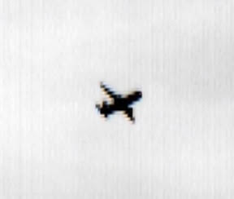
Figure 5. Thermal image at 30X magnification

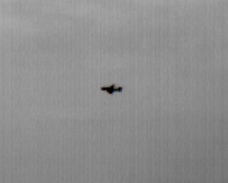
Figure 6. Thermal image at 25X magnification

Figure 5 was taken with an HD FLIR thermal camera in the black-hot setting, magnified at 30x. The image depicts an airliner at an altitude of 30,000 feet. Figure 6, captured with the same type of camera at a 25x zoom in the black-hot setting, shows another airliner at 28,000 feet.
In both images, the temperature differential between the high-altitude sky and the internal heating within the fuselage produces a black silhouette thermal signature. This effect occurs because the air at such altitudes can be significantly colder than –40 degrees, whether measured in Fahrenheit or Celsius. When a wide temperature range exists but the thermal camera has a limited detection span, the result is a restricted range within the color palette.¹⁴
Using LW FLIR Thermal Imaging to Detect Possible Thermal Inversions. The HD monocular FLIR camera also provides well-defined atmospheric temperature gradients when displayed in a rainbow color palette. This method offers a unique way to identify temperature inversions, which may produce radar reflection artifacts and compromise RF data. The rainbow palette, although similar to the iron bow palette, expands the range of colors by assigning higher-wavelength hues to the hottest portions of the image and lower-wavelength hues to the coldest portions. This approach enhances contrast along subtle temperature boundaries, which may otherwise be difficult to discern.
This imaging method is particularly suitable for detecting temperature layer boundaries in the atmosphere. To ensure accuracy, such scans are conducted several times each night during field investigations, accounting for atmospheric conditions that might otherwise degrade radar results.¹⁵

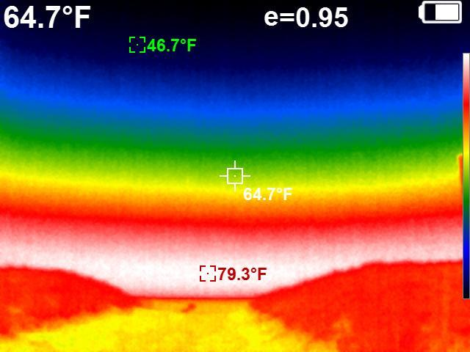
Figure 7. Thermal image using a Rainbow palette to show temperature gradation

For Figure 7, note the gradual temperature difference depicted as layers transitioning from a warmer surface temperature to cooler temperatures at higher altitudes. These variations are displayed in color gradients using a rainbow palette. The image, taken at Robert Moses State Park (RMSP) with a handheld FLIR camera, represents normal atmospheric temperature gradients. The thermogram demonstrates the absence of a temperature inversion.¹⁶
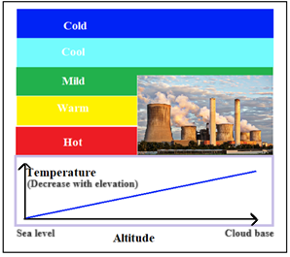
Figure 8. Normal temperature gradation

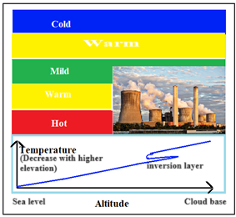
Figure 9. Atmospheric temperature inversion

Figures 8 and 9 are illustrations comparing a normal atmospheric temperature gradient with an atmospheric temperature inversion. Figure 8 demonstrates a typical linear progression of temperature change with altitude, while Figure 9 depicts a gradient that does not follow this linear progression, indicating the presence of an inversion.¹⁷
Field Excursions and Results. Field excursions conducted between July 2025 and August 2025 established the pilot study for first responders. This research investigation involved data collection and analysis using a portable platform based on the Tedescos’ four-year research initiative, Eye on the Sky.¹⁸ This platform established the protocol and working model for a scaled-down version intended for use by first responders.
Structured Field Excursions. Six structured field excursions were carried out at multiple locations in Suffolk County, New York. Each deployment followed strict protocols for environmental logging, sensor calibration, and post-event data analysis.
- Excursion One – July 5, 2025, Robert Moses State Park
Figures 10 and 11are screenshots of videos showing a luminous object detected simultaneously on optical and thermal imaging devices. The object was tracked and recorded hovering at low altitude, moving inland from over water before disappearing without a discernible trajectory.

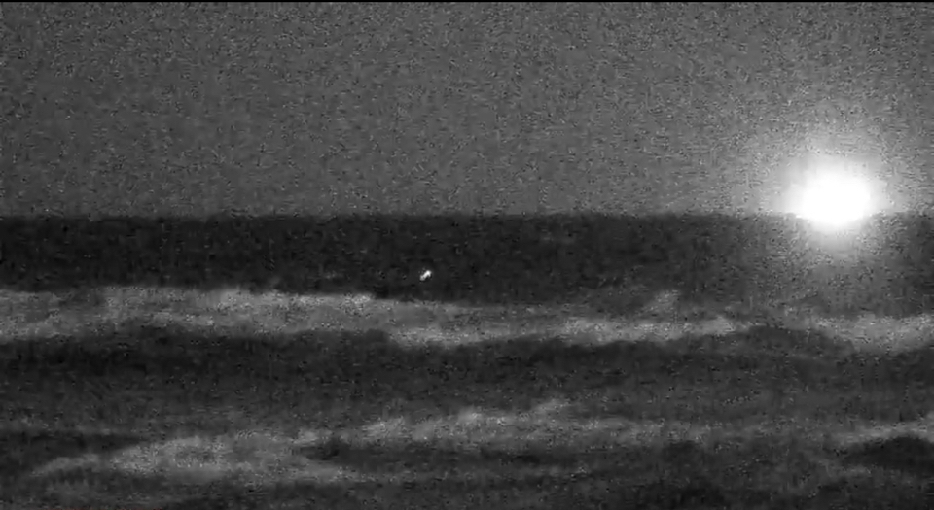
Figure 10. Luminous object detected over water, Robert Moses State Park

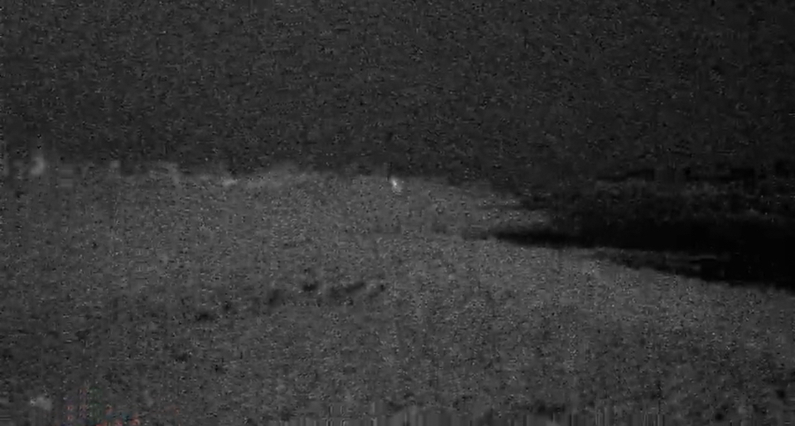
Figure 11. Luminous object moving inland from the water, Robert Moses State Park

- Excursion Two – July 19, 2025, Robert Moses State Park
Figure 12 is a screenshot of a video showing a luminous object detected and recorded on a night vision optical imaging device. The object appeared stationary for approximately ten to fifteen minutes, hovered at low altitude over water, and then quickly disappeared without a discernible trajectory.

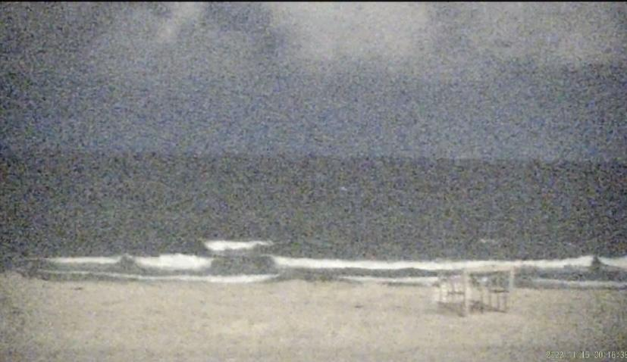
Figure 12. Luminous object detected over water, Robert Moses State Park

- Excursion Three – July 25, 2025, Robert Moses State Park
No significant anomalies were detected utilizing the team’s multimodal instruments.
- Excursion Four – July 26, 2025, Camp Hero State Park
Figure 13 is a screenshot of a video of a luminous object recorded on optical imaging. The object hovered at low altitude before disappearing without a discernible trajectory. Additionally, figure 14 is a screenshot of a video showing several spherical anomalies appearing in sequence. Radar logs indicated unpredictable movements, while optical imaging captured various geometric formations.

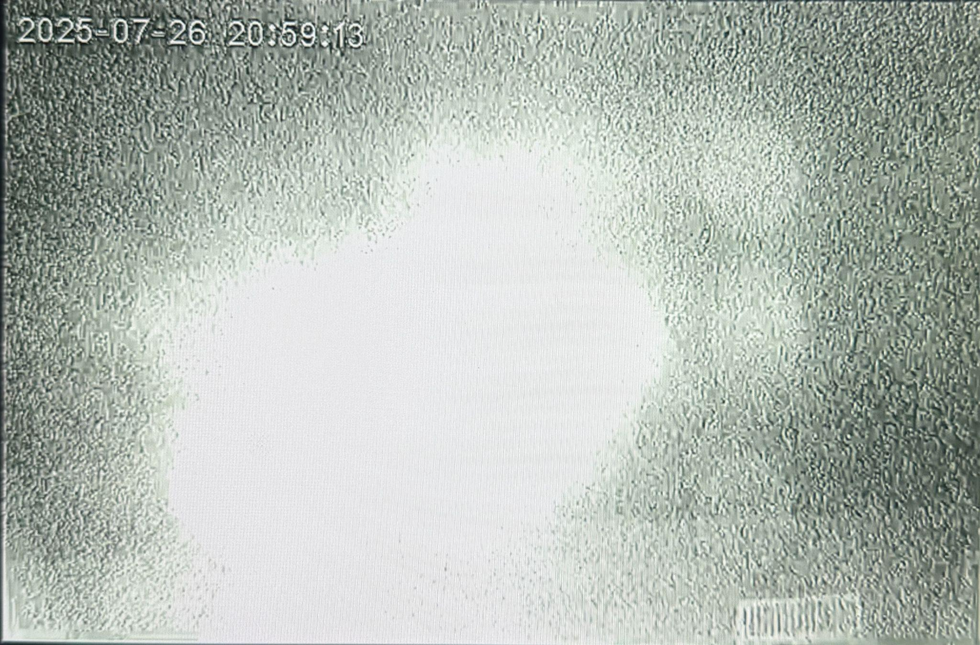
Figure 13. Luminous object recorded by night vision optical imaging, Camp Hero State Park

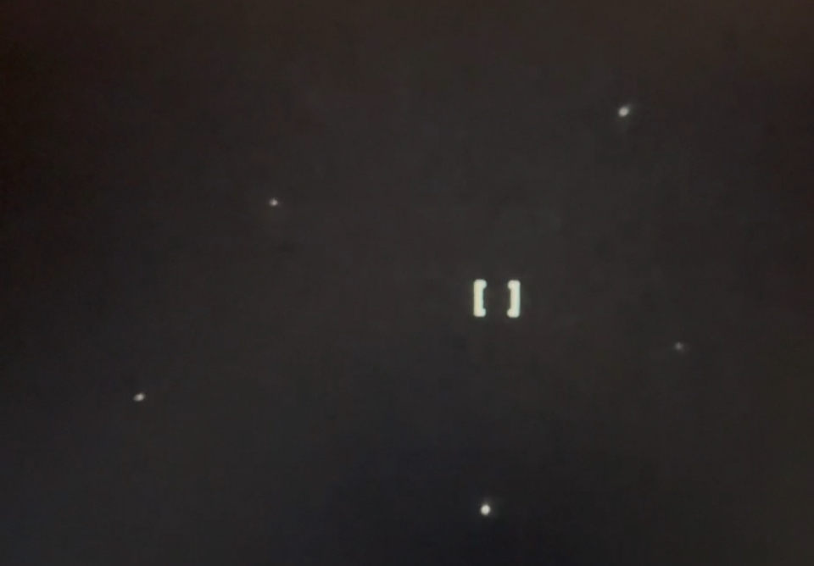
Figure 14. Luminous objects recorded by night vision optical imaging forming a geometric shape of a five pointed star, Camp Hero State Park

- Excursion Five – August 2, 2025, Robert Moses State Park
Figure 15 is a screenshot of a video of a luminous object detected and recorded on optical imaging. The object appeared momentarily, hovered at low altitude over water, and then quickly disappeared without a discernible trajectory. Additionally, three luminous objects were tracked and recorded in a triangular geometric configuration as shown in figures 16 and 17 showing screenshots of a video recording of the night vision optical imaging.

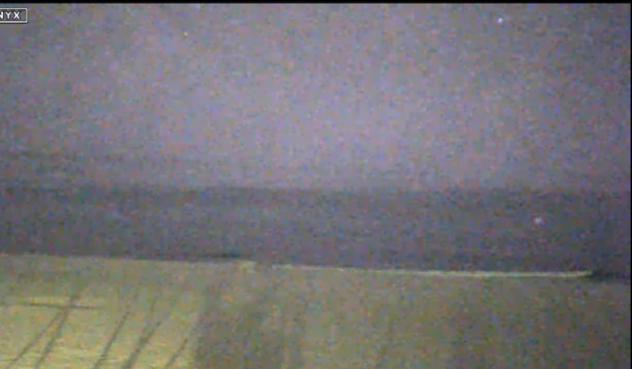
Figure 15. Luminous object detected over water, Robert Moses State Park
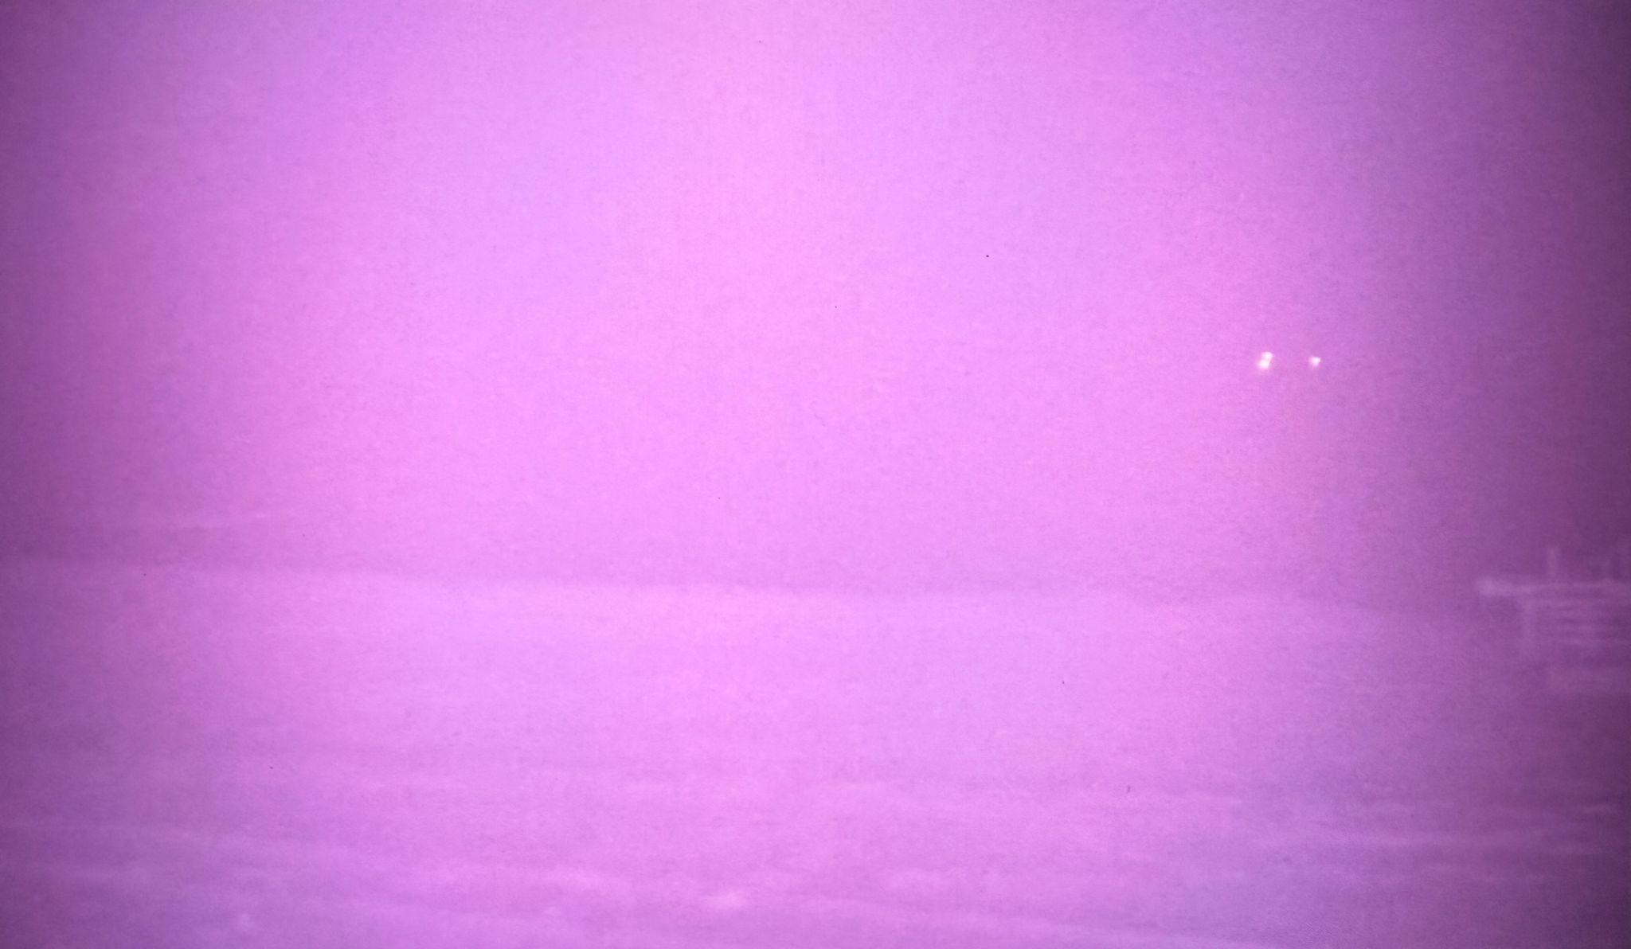
Figure 16. Three luminous objects over water in a triangular geometric configuration, Robert Moses State Park

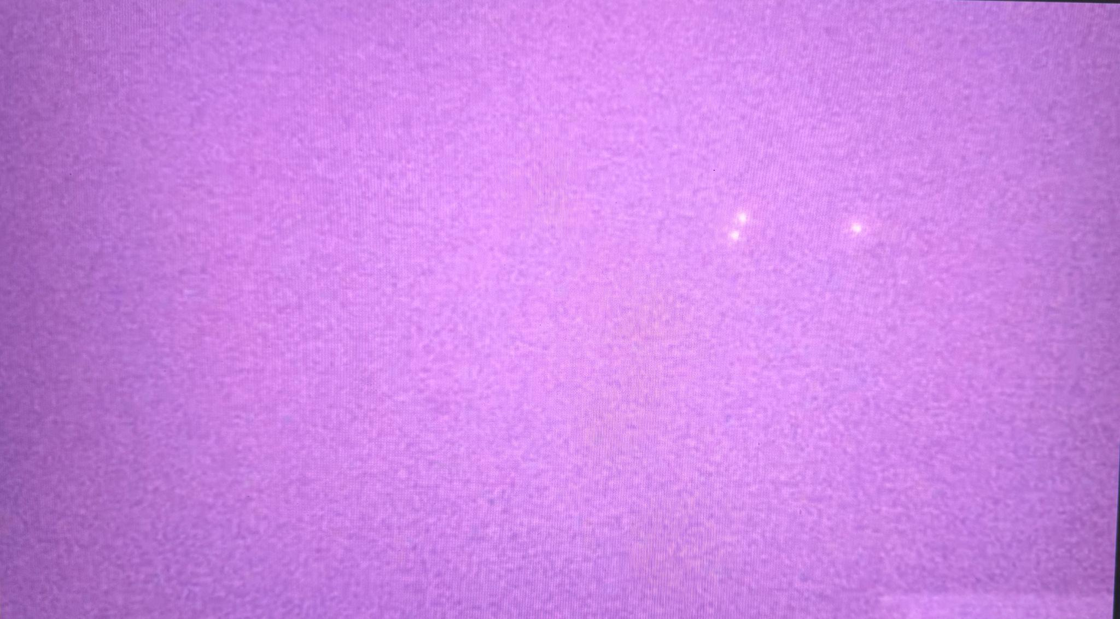
Figure 17. Closeup view of three luminous objects over water in a triangular geometric configuration, Robert Moses State Park

- Excursion Six – August 6, 2025, Cedar Beach, Babylon
No significant anomalies were detected utilizing the team’s multimodal instruments.
The Tedescos’ six excursions collectively highlight the utility of coordinated multimodal sensing for confirming UAP events. While not every deployment yielded anomalies, the methodology establishes a reproducible foundation for future law enforcement and research collaborations.¹⁹
The six field excursions conducted between July and August 2025 demonstrated the operational feasibility of coordinated multimodal detection. While not every deployment produced anomalous data, the consistency of environmental logging, sensor calibration, and instrument synchronization validated this as a reproducible model for future law enforcement research (Table 1).

Table 1. Summary of Field Excursions
Excursion | Location | Date | Result
1 | Robert Moses State Park | July 5, 2025 | Luminous object over water, optical & thermal confirmation
2 | Robert Moses State Park | July 19, 2025 | Stationary luminous object over water, disappeared abruptly
3 | Robert Moses State Park | July 25, 2025 | No anomaly detected, baseline data established
4 | Camp Hero State Park | July 26, 2025 | Luminous object hovering low altitude, multiple anomalies recorded
5 | Robert Moses State Park | August 2, 2025 | Triangular luminous formation detected and tracked
6 | Cedar Beach, Babylon | August 6, 2025 | No anomaly detected, baseline confirmation

Policy Framework for Law Enforcement Preparedness. The unpredictable nature of UAP incidents has renewed calls for law enforcement preparedness. Both former AARO Acting Director Tim Phillips and current Director Jon Kosloski have emphasized the importance of integrating state, local, and tribal officers into the federal framework for UAP research and response.²⁰
Phillips, in a November 2024 professional discussion with Dr. Keith Taylor, highlighted how patrol officers often serve as the first—and sometimes only—official witnesses to UAP events. He noted that agencies must address occupational vulnerability by equipping officers with clear reporting protocols, protective guidance, and pathways for interagency data-sharing.²¹
Kosloski, in public remarks during his August 2025 StarTalk interview, extended this vision by proposing a structured role for law enforcement within AARO activities. His plans include standardized officer reporting forms compatible with federal databases, training modules for recruits and in-service officers on UAP recognition and response, and the expansion of larger, more widely distributed sensors tied in with those of other U.S. government organizations. These measures are intended to ensure that rural and suburban agencies remain connected through partnerships across the federal government, private citizens, and academia.²²
Both perspectives underscore that the future of UAP policy depends on formalizing law enforcement involvement. Just as officers were once trained in hazardous materials recognition for counterterrorism preparedness, UAP incident preparedness must become a necessary component of public safety operations.
Discussion and Analysis. When analyzed together, the incidents and fieldwork presented in this article reveal three key insights:
- Occupational Hazard Dimension – Law enforcement officers are uniquely vulnerable to UAP encounters due to the isolated and unpredictable nature of patrol work. Historical and modern cases reveal both officer-involved physical injuries and psychological trauma from UAP incidents.
- Instrumental Verification – The Tedesco brothers’ multimodal fieldwork demonstrates that UAP incidents can be validated beyond anecdotal testimony. This approach holds promise for strengthening credibility for both law enforcement response and mitigating significant public stigma.
- Policy Integration – Past and current leadership at AARO are actively seeking ways to bridge the gap between scientific research and officer safety. Phillips and Kosloski’s complementary positions highlight the need for standardized training and detection technology, data integration, and interagency collaboration.
The convergence of these insights suggests that UAP should be approached as both a scientific mystery and a public safety issue. Only by addressing both dimensions can agencies ensure officer safety while advancing credible knowledge.
Conclusions. The analysis confirms that UAP encounters present legitimate occupational hazards requiring institutional awareness. Through the Tedescos’ multimodal detection protocols, law enforcement agencies can transition from subjective reports to measurable evidence, improving both officer safety and scientific rigor. Policymakers and agencies such as AARO must formalize training, reporting standards, and sensor integration to embed preparedness across local and national frameworks. Future development should focus on scalable mobile detection systems and cross-sector data collaboration.
The cumulative evidence presented in this article demonstrates that Unidentified Anomalous Phenomena are not only a matter of scientific mystery but also a law enforcement occupational concern. Historical incidents such as the 1979 Marshall County vehicle collision, contemporary cases like Officer Robert Klein’s 2022 Fairfield County encounter, and more recent public interviews by AARO’s former and current leadership emphasize the persistent vulnerability of frontline law enforcement officers. The highlighted incidents underscore that UAP encounters are capable of producing physical harm, impairing officer judgment, and compromising operational safety.
The field investigations of John and Gerald Tedesco further strengthen this case. Their deployment of multimodal sensors in Suffolk County, New York, demonstrates that anomalous phenomena can be documented in systematic, replicable ways. By bridging anecdotal testimony with measurable data, the Tedescos’ work offers a model for how law enforcement agencies might enhance both credibility and preparedness in future encounters.
At the federal level, the evolving role of AARO—first under Acting Director Tim Phillips and now under Director Jon Kosloski—signals an emerging recognition that local, state, and tribal police officers represent critical stakeholders in UAP response. Planned initiatives for standardized reporting, officer training and equipment, and interagency coordination reflect a path forward that integrates state and local law enforcement into the broader national framework of UAP monitoring, research, and response.
Taken together, these developments suggest that a comprehensive framework for law enforcement UAP incident response preparedness is both necessary and achievable. Such a framework would better prepare law enforcement officers in the field, improve data fidelity through multimodal documentation, and foster collaboration across local, state, and federal levels. In doing so, it would elevate UAP encounters from isolated incidents to structured opportunities for scientific, security, and operational advancement.

References
- UAPMED, Case Study 10: Police Response to the 1979 Marshall County Minnesota UAP Incident.
- Damita Menezes, “Police Officer Captures Video of Suspected UFO in Connecticut,” NewsNation, November 27, 2024.
- Jon Kosloski, interview by Neil deGrasse Tyson, StarTalk podcast, August 2025.
- Professional conversation between Acting Director Tim Phillips and Keith Taylor, November 2024.
- Author analysis.
- The Port Authority of New York and New Jersey, Annual Air Traffic Report, JFK Airport, 2023.
- Hamamatsu Photonics, Technical Datasheet on Binary Phototube Detectors, 2024.
- Tedesco Brothers, UVC Detector Design Notes, unpublished field documentation, 2023.
- Federal Communications Commission, Automatic Dependent Surveillance–Broadcast (ADS-B) Overview, 2023.
- AirNav Staff, Air Traffic Surveillance Tools and Services, 2019.
- Wei Huang, Thermal Imaging and Infrared Signature Analysis, 2016.
- Technical specifications of the ATNOTS 4T FLIR thermal system and thermal capacitance data, manufacturer documentation.
- See technical discussions on zoom functionality in photography, Leibovitz 2023.
- Technical specifications of HD FLIR thermal cameras, manufacturer data.
- Field research methodology notes, UAP thermal inversion studies.
- Field observation with handheld FLIR imaging equipment, Robert Moses State Park.
- Illustrations of atmospheric gradients created for field research documentation.
- John and Gerald Tedesco, Eye on the Sky Research Program, 2021–2025.
- Field notes, Suffolk County research excursions, July–August 2025.
- Professional discussion between Tim Phillips and Dr. Keith Taylor, November 2024.
- Ibid.
- Jon Kosloski, StarTalk podcast interview, August 2025.
References
1. Vallée, J. Dimensions: A Casebook of Alien Contact. Contemporary Books, Chicago–New York, 1988.
2. UAPMED. Case Study 10: Police Response to the 1979 Marshall County Minnesota UAP Incident.
3. Damita Menezes. 'Police Officer Captures Video of Suspected UFO in Connecticut.' NewsNation, November 27, 2024.
4. Jon Kosloski. Interview by Neil deGrasse Tyson. StarTalk Podcast, August 2025.
5. Professional conversation between Acting Director Tim Phillips and Dr. Keith Taylor, November 2024.
6. John & Gerald Tedesco. Eye on the Sky Research Program, 2021–2025.
7. Hamamatsu Photonics. Technical Datasheet on Binary Phototube Detectors, 2024.
8. Tedesco Brothers. UVC Detector Design Notes, unpublished field documentation, 2023.
9. Federal Communications Commission. Automatic Dependent Surveillance–Broadcast (ADS-B) Overview, 2023.
10. AirNav Staff. Air Traffic Surveillance Tools and Services, 2019.
11. Huang, W. Thermal Imaging and Infrared Signature Analysis, 2016.
12. Technical specifications of the ATNOTS 4T FLIR thermal system and thermal capacitance data, manufacturer documentation, 2023.

